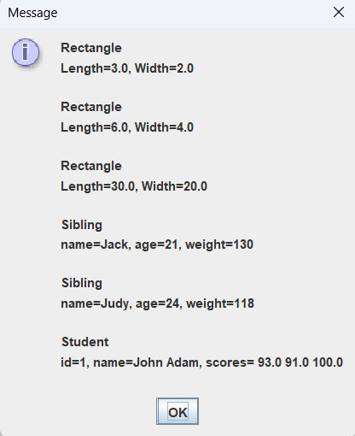

package as09;

//File: TestStatus.java
import javax.swing.JOptionPane;

public class TestStatus
{
public static void main(String[] args)
{
String in, out;
// Create an array of 6 Status references
Status[] status = new Status[6];
int statusIndex = 0;

// Create three Rectangle objects
for (int i = 0; i < 3; i++)
{
in = JOptionPane.showInputDialog("Enter length");
double length = Double.parseDouble(in);
in = JOptionPane.showInputDialog("Enter width");
double width = Double.parseDouble(in);
status[statusIndex] = new Rectangle(length, width);
statusIndex++;
}

// Create two Sibling objects
for (int i = 0; i < 2; i++)
{
in = JOptionPane.showInputDialog("Enter name");
String name = in;
in = JOptionPane.showInputDialog("Enter age");
int age = Integer.parseInt(in);
in = JOptionPane.showInputDialog("Enter weight");
int weight = Integer.parseInt(in);
status[statusIndex] = new Sibling(name, age, weight);
statusIndex++;
}

// Create one Student object
for (int i = 0; i < 1; i++)
{
in = JOptionPane.showInputDialog("Enter student id");
int id = Integer.parseInt(in);
in = JOptionPane.showInputDialog("Enter student name");
String name = in;
in = JOptionPane.showInputDialog("Enter number of scores");
int numScores = Integer.parseInt(in);
double[] scores = new double[numScores];
for (int j = 0; j < numScores; j++)
{
in = JOptionPane.showInputDialog("Enter score " + (j + 1));
scores[j] = Double.parseDouble(in);
}
status[statusIndex] = new Student(id, name, scores);
statusIndex++;
}

// First Polymorphic Loop - Call displayStatus()
for (int index = 0; index < status.length; index++)
{
status[index].displayStatus();
}

// Second Polymorphic Loop - Call getStatus() and accumulate output
out = "";
for (int index = 0; index < status.length; index++)
{
out = out + status[index].getStatus();
}
JOptionPane.showMessageDialog(null, out);
}
}

